YOUTH PRACTICE
HANDBOOK

Table of Contents
COACHING PHILOSOPHIES……………………………………………………………………………………………………………….2
MAKING PRACTICE FUN…………………………………………………………………………………………………………………………4
PRESEASON PRACTICE CHECKLIST………………………………………………………………………………………………………….6
GAME SEASON PRACTICE CHECKLIST…………………………………………………………………………………………………….7
WARMUP/CONDITIONING EXERCISES……………………………………………………………………………………………………8
Dynamic Stretches……………………………………………………………………………………………………………8
Core Strength Exercises…………………………………………………………………………………………………….9
Fun Conditioning Exercises……………………………………………………………………………...................10
THROWING PROGRAM…………………………………………………………………………………………………………………………11
Throwing Program Drills……………………………………………………………………………………………………11
DAILY DRILLS………………………………………………………………………………………………………………………………………13
Infield………………………………………………………………………………………………………………………………13
Outfield…………………………………………………………………………………………………………………………..14
Catchers…………………………………………………………………………………………………………………………..16
Hitting……………………………………………………………………………………………………………………………..17
AGE SPECIFIC DRILLS……………………………………………………………………………………………………………………………22
Hand-Eye Coordination…………………………………………………………………………………………………….22
Baserunning……………………………………………………………………………………………………………….…23
PRACTICE PLANS………………………………………………………………………………………………………………………………….25
Pre-Season………………………………………………………………………………………………………………………25
In Season………………………………………………………………………………………………………………………..27

YOUTH COACHING PHILOSOPHIES

Importance of Practice
Practice should be treated with more importance than games. On the development side of baseball, we can only improve with repetition. In a game setting, a player gets at most five at bats and may only get one or two balls hit to them all game. That is not nearly enough reps to improve a skill. In fact, if we take practice for granted or stop practicing altogether during the season, players’ skills will decline. MAKE SURE YOU RELAY THE IMPORTANCE OF PRACTICE TO YOUR PARENTS. A COUPLE PLAYERS MISSING FROM PRACTICE WILL LIMIT THE QUALITY OF WORK YOU CAN ACCOMPLISH.
Come with a Plan
Have a written plan for every practice. Players will take notice if you are, or are not organized for practice. Practices that are not well organized will cause players to lose interest and focus quickly.
Create Routines
The basis for building skills in practice will be routines. Every practice should contain several skill building drills or exercises that players know, and can practice at home if they choose. These drills and exercises should be done every time the team meets. It is important to create consistency in how the team practices and there is familiarity for the players. Teams should have a throwing routine, fielding drill routine, and a hitting routine.
Control the Energy of Practice
Try to come to every practice with a positive mood. Be positive in your language and don’t be afraid to have fun. Bring as much energy as you can. Kids will feed off of your energy. The more fun you have in practice, the more effort the kids will give you.
Nurture Athleticism
Athletic ability should be practiced and developed. Use dynamic stretching, agility drills, core strengthening exercises and any other methods you can to develop your players’ athleticism. Make the exercises fun and a regular part of your practice routine.
Eliminate Fear
Much of young players’ failures in baseball can be traced to a single source; FEAR. We should be trying to eliminate the fear of failure, fear of the ball, fear of coaches’ and parents’ reactions, etc.
- Fear of Failure
In practice we should create game-like situations in which the players can have success, but also fail. Encourage players to pick each other up and encourage each other after mistakes. Model that behavior by being encouraging to players who make mistakes. Yelling will only make players shut down and fear failing even more.

- Fear of the Ball
Use softer balls or other objects in practice to help alleviate the fear of getting hit. Tennis balls are great for this. Practice getting hit by pitches with tennis balls or wiffle balls. Also practice using their chest to keep the ball in front of them on a chopper. This will teach them to stay square and not pull away from the ball as they field.
- Fear of Adult Reactions
First, we need to control our own emotions and reactions. The best coaches in baseball are stoic, and show little outward emotion throughout games. If you often react to errors or bad plays, players will begin to expect it and look for it. This will create a distraction and induce fear. Second, we need to communicate with our parents the importance of not yelling or being negative towards players. Lastly, we need to encourage players to not look for reactions from us and to talk to and encourage each other. A Confident team does not constantly look into the dugout or stands after every play.

Praise Effort
Praise the controllable aspects of the game and practice; attitude, effort, hustle, coachability, etc. More weight should be placed on praising these aspects than praising success in games. Players will bounce back from failure better and be more likely to work hard for you in practice when they know that effort is what you value most.

MAKING PRACTICE FUN
Blocked vs Random
A blocked drill is one in which the player knows exactly what is coming and can focus completely on the task at hand. For example, coaches rolling infielders a backhand ground ball every time they work through the drill line is a blocked drill. A random drill is one in which the player must make a decision or has cognitive interference. For example, in that same drill line, now coaches will roll backhands, forehands and slow rollers randomly so that the player must make a decision on how to field it. Make sure you use both blocked and random drills at practice. The younger the group the more blocked skill work they need, however, that does not mean they do not also need random drills. The more they get used to making quick decisions in game like settings, the sooner it will transfer into the actual games.
Make Players Communicate
Drill work and fun team building exercises can be used to create a communicative culture on your team. Add communication into drills that may not already have it. For example, if you are doing a four corner or around the world throwing drill, have players call out the person’s name before they throw the ball to them. Competitions also foster a talkative environment. Use relay style races, hitting competitions, last man standing fielding drills, etc. and your team will surely start to talk to one another. Also, during situation practice or scrimmage style practices we need to constantly be encouraging the players to talk and communicate before the pitch, during the play, and after the play. Coaches should not have to tell players the outs. They should be communicating outs to each other after each play.
Stations & Rotations
Stations are small groups of 2 or 3 players (4 to 5 groups) and each drill only lasts 2 to 5 minutes before groups rotate. Rotations are larger groups of 4 to 6 players (2 to 3 groups) and each exercise lasts longer (10 to 20 minutes) before each rotation. Use both stations and rotations during practice to keep it moving along and keep players active and engaged.
Be Unconventional
Do not be afraid to be unconventional in your practice methods. Practice should not be just hitting some ground balls and fly balls to the players, taking some batting practice and calling it a day. Search for different ways to add creativity into your practice methods.
Targeting
Use targets often in practice. Targets can be used for throwing and hitting. Players love the challenge of trying to hit a target, and will unconsciously focus more intently on the task at hand.

Training Tools and Equipment
Some items are a must have to make practice efficient. Tees and wiffle balls are essentials. Other fun items to use include paddles or other flat devices to use in place of gloves. Coaches of younger teams can use bean bags to work on hand eye coordination and using the glove hand properly to catch. You can use footballs to work on tracking balls in the outfield. Agility ladders can be used for all sorts of fun exercises. Be creative. Players will love using different training tools and equipment they may have never used before.
Constant Activity
Pace of practice is the most important factor in keeping players engaged. Let’s not kid ourselves, baseball can be boring. But it does not have to be. Using drills, exercises, stations, rotations, and utilizing all space and volunteers will create a fast pace, high energy practice that kids will love participating in.
Drills
Drills are the cornerstone to practice and player development. Along with the drills included in this guide, there are thousands of them you can find on YouTube, in books, and in other online resources. Feel free to use any drill you would like if you can communicate the purpose of the drill, keep it moving at a good pace, and the players are getting value out of it.
Competition
Everyone likes a little competition. Have at least one competition each day in practice. You can turn just about any drill or exercise into a competition. Or simply create a hitting, pitching or fielding competition with your team divided up into 2 or 3 mini teams. This will be a part of practice your players will always look forward to with excitement.
Purpose
Make sure there is a purpose behind everything that you do in practice. Communicate the purpose to your team for each activity. If something seems pointless, players will pick up on that and lose focus.
Challenge Them
As coaches we should be constantly pushing our players to get better. While younger players do need lots of repetition and to experience lots of success, they also need to be challenged to keep interest. A good guide is to practice 80% of the time on skills that players already know and have a high rate of success with, and 20% on skills and concepts that are difficult for them and have a high rate of failure.

PRE SEASON PRACTICE CHECKLIST
Preparing for Game Season
- Long Toss
- Fungo Pop ups
- Fungo Ground Balls
- Hitters standing in against live pitchers
- Competition
- Bullpens (Pitchers throwing to catchers)
Skill Building
- Daily infield drills
- Daily outfield drills
- Daily hitting drills
- Daily catcher’s drills
- Throwing Program
Team Concepts
- Cuts and Relays
- Backup assignments
- Positioning (straight up, infield in, no doubles, double play depth, corners in)
- Rundowns
- Pitchers Fielding Practice (covering first base, turning double play, fielding bunt)
- Lead offs and Steals
- Pickoffs/Holding Runners on
- Bunt Defense
- First and Third Defense
- Baserunning and sliding
- Pop up communication
Situations
- Vary runners at all bases
- Vary outs
- “Infield In” situations
- “No Doubles” situations
- “Corners In” situations
- Double Play situations
- Move players around to different defensive positions (or make rotations)
- Use live hitters or coaches fungo
- Use live baserunners when possible or ghost runners

GAME SEASON PRACTICE CHECKLIST
Everyday Practice Essentials
- Daily infield drills
- Daily outfield drills
- Daily catchers’ drills
- Throwing program
- Fungo groundballs
- Fungo flyballs
- Competition
Review Team Concepts as Needed
- Cuts and Relays
- Backup assignments
- Positioning (straight up, infield in, no doubles, double play depth, corners in)
- Rundowns
- Pitchers Fielding Practice (covering first base, turning double play, fielding bunt)
- Leadoffs and Steals
- Pickoffs/Holding Runners on
- Bunt Defense
- First and Third Defense
- Baserunning and Sliding
- Pop up communication
Revisit Situations from Games that Need Additional Teaching
We need to work on:
Week 1 _____________________________________________________________________________
Week 2 _____________________________________________________________________________
Week 3 ______________________________________________________________________________
Week 4 ______________________________________________________________________________
Week 5 ______________________________________________________________________________
Week 6 ______________________________________________________________________________
Week 7 ______________________________________________________________________________
Week 8 ______________________________________________________________________________

WARMUP/CONDITIONING EXERCISES

Dynamic Stretches
Cherry Pickers – Skip and try to get as high as possible, while reaching as high as possible with the hand opposite the foot you are skipping off. The purpose is height, not speed or distance. It should take many skips to go the full distance. Distance: 30 feet.
Side Lunges - Working perpendicular to the line, step sideways as far out as you can go and lean into your lead leg, while keeping back leg straight. Turn to face the opposite way and repeat on the opposite side. Continue repeating each side until you complete the distance. Distance: 30 feet.
Slalom Bounding – Beginning on left foot, jump diagonally to your right, landing only on your right foot. Briefly hold this landing position, and then jump diagonally to your left landing only on your left leg. Again hold position briefly, and then continue bounding back and forth diagonally onto each leg until the distance is completed. Distance: 30 feet.
Frog Jumps (one leg & two legs) – Do a frog jump out as far as you can, while still being able to land cleanly. Continue until past the coach. You can do two leg and one leg jumps. Distance: 30 feet.
Line Hops (one leg & two legs) – Lateral two feet: with your feet parallel to the line, hop side to side over the line as quickly and controlled as you can. The hops should be very small and your foot should stay very close to the sides of the line throughout the drill. Forward two feet: with your feet perpendicular to the line, hop forward and backward over the line as quickly and controlled as you can. The hops should be very small and your toes and heels should stay very close to the sides of the line throughout the drill. Drill can also be done one foot at a time. Reps: 30 each.

Lunge and reach – Lunge forward with one leg. Reach with opposite elbow toward ground. Raise other arm to the sky. Repeat on other side, walking forward as you alternate legs. Distance: 30 feet.
Field Goal Kickers – Hold arms out straight. Kick right foot up to your right hand. Keep your leg straight. Walk forward as you alternate legs. Distance: 30 feet.
Leg Swings (Forward & Lateral) – Hold yourself up using a wall or fence (perpendicularly for forward, parallel for lateral). Swing your leg forward or laterally, maintaining good posture. Focus on dynamically stretching your hips. Sets/Reps: 3x10 each leg.
Bodyweight Squats – Stand with feet just beyond the distance of your hip width, toes facing forward. Cross arms across chest with each hand on opposite shoulder. Sit back like you are sitting in a chair behind you without allowing your knees to drift beyond your toes. Sit back until about a 90 angle is made at your knees and come back to standing. Reps 8 to 12, progressing as athletes get better at form.
Deep Bodyweight Squat – Begin standing with feet slightly past shoulder width apart, toes pointed forward. Follow same form as normal squat, but continue down well past 90 degrees at the knee (as deep as possible). Keep knees behind toes and avoid arching back. Hold position. Begin with 15-20 seconds. If form is good, add time and/or reps.

Core Strength Exercises
Front Plank – Have both elbows on ground directly underneath shoulders. Try to keep a straight line from feet to shoulders. Don’t let the midsection drop or be too high. Progression options- Raise the right leg, then left leg and hold, or raise the opposite arm and leg straight out.
Side Plank – Have one elbow on the ground directly beneath the shoulder. Keep the body in line from feet to head, and don’t let the body sag in the midsection; alternate sides. Progression options - Raise the free arm straight up in the air, or raise the top leg on the stacked feet into the air.
Side Arm Balance – Same position as side plank, but with bottom arm extended and hand on the ground. Keep the body in a straight line from feet to head. Do not let the midsection sag. Stack the feet. Progression options - Raise the top leg on the stacked feet in the air.
Plank Leg/Arm Extension - Start in plank position, extend the opposite arm and leg off the ground. Try to keep the body in as straight a line as possible. Hold for three to six seconds. Progression options - Add a pushup between each rep.
Glute Bridge – Start laying flat on back, legs together, feet straight out. Bring feet up so that they are directly underneath your knees and your shoulders are the only other part of your body touching the ground. Maintain a straight line between the shoulders and knees with the pressure in the feet on the heels. Progression options - Raise each leg off the ground and hold for three to six seconds.
Push-Ups & Knee Push-Ups - Start in up position. On coach’s cue, take chest down toward the ground. Try to keep a straight line from feet to shoulders. Don’t let the midsection drop or be too high. Chest should get between 1 and 2 inches from the ground without touching. Push back up to extended arm, up position. Depending on the strength level of athlete, you can also do the push-ups from the knees, while still keeping back as straight as possible.

Fun Conditioning Exercises
Wide receiver/Defensive back - Pair athletes up who have similar athletic abilities. Select one to be the wide receiver and one to be the defensive back. Have them start from about 15 feet to the side of the coach (quarterback) who has a bucket of baseballs (CAN ALSO USE FOOTBALL OR OTHER TYPE OF BALL). The coach says “go” and the wide receiver has to try to get open and catch a pass from the coach. Make them run a good distance each time they go out for a pass. Next time that pair comes up, have them switch wide receiver and defensive back.
Two Team Relay – Split your team into two even groups with approximately equal speed in each group. Have one group at home plate and the other at second base. On the coach’s call, the first runners have to run around all four bases, tagging the next teammate in line’s hand as he crosses the base in which he began. The next runner can leave immediately as his teammate tags his hand. Have players sit down after they have gone. First team to finish wins.
Triple relay - Divide your teams in to groups of four. If someone has less than four, one member of that group goes twice. One member of the team starts at each base. The runner at home plate runs a triple. When he gets to third, the runner from third runs a “triple” from third base to second base. Then the runner from second runs a triple to first, and the runner from first runs a triple to home. The coach should time the group from when the first player starts until the last player crosses home plate.
Obstacle course – There is no specific way to set up a perfect obstacle course on the field, but be creative. Have some baserunning, a section where they have to do one of our dynamic warm up or agility exercises and a section where they have to skip, bear crawl, run backward and/or sprint in a straight line. Create relay teams to race or just have them go through individually and you can time them. You can keep the same obstacles each time or change them up to keep it interesting. Be creative and have fun. BE CREATIVE AND MAKE UP YOUR OWN FUN WARM UP/CONDITIONING EXERCISES!

THROWING PROGRAM

This is an often overlooked or underappreciated segment of practice. However, the ability to play catch will be one of, if not the most, important factor in your teams’ success this season. Do not use terminology such as “GET LOOSE” or “WARM UP.” Tell your players that it is time for your “THROWING PROGRAM” OR “THROWING PRACTICE.” Stress focus. Players should not be talking excessively during this time. Coaches should be monitoring at this time making sure players are taking the program seriously. Set a minimum amount of time to be spent on this daily.

Throwers should be focusing on targeting their partners and throwing to the middle of their chest or head. Throwers should also focus on using their feet to create momentum toward their intended target. Make sure every player is either shuffling or stepping through toward their target on every throw to create the momentum. (STEP THROUGH FOR RH THROWERS IS RIGHT FOOT FIRST, TURNING INSTEP TOWARD TARGET, THEN LEFT FOOT WHICH SQUARES PLAYER’S SHOULDERS AND FEET UP WITH TARGET. FOR LH THROWERS, IT IS LEFT FOOT, THEN RIGHT FOOT.)

Receivers should be in an athletic, ready position. Have younger players and those that struggle with catching the ball show a target with two hands about shoulder or head height, making sure their fingers are pointing to the sky. When ball is thrown they should be ready to move in any direction to go get the ball. Receivers should be taught that they are the ones who cut down on bad throws by having quick feet and attacking the thrown ball.

*One tip for limiting the amount of time lost on chasing bad throws is to have every player carry an extra ball in their pocket.*

Throwing Program Drills

Strong Front Side Drill

Purpose: Create proper mechanical use of the glove arm and front side of the thrower’s body, which in result will fix many mechanical deficiencies.

Procedure: Thrower will start in athletic position lined up perpendicular to their target. They will get their front arm up in a strong position so that their elbow is pointing at their target. Keeping front arm and elbow in position, they will shuffle twice toward their target and throw. Elbow should turn down (glove turns up) and their chest should be taken to the glove as they throw.

Quick Toss Drill

Purpose: Works players’ footwork and glove to hand transfer ability, as well as ability to work quickly under pressure.

Procedure: Set up about 20 to 30 feet apart depending on age and ability. Players will start on your que, and try to get the ball back and forth to each other as quickly as possible. Focus should be on quick feet turning themselves back square to their target, and on a quick transfer out of their glove.
Bonus: As players get better, you can challenge them by implementing a 30 second clock and have them count how many throws they can make in the allotted time.

Target Practice Drill

Purpose: Improve players throwing accuracy and get them to practice focusing on a target when they make their throws.

Procedure: Start with all baseballs on one side of the throwing lines. Make sure lines are even and straight. Players should be at a moderate distance (base distance or slightly further). On your whistle or mark, players will throw ball to partner. Partners are instructed to put hands up and show themselves as a big target facing the thrower with feet pointing straight toward them. If the receiver makes the catch without moving his feet they are awarded a point. If the receiver does not catch the ball without moving or the ball bounces before he catches it, they receive no points. Players keep track of their own points and only throw on your whistle or mark. Winner has most points at end of game.

Bonus: As players get better at playing catch, you can make the game more challenging by making the target area only the chest or head of the receiving player. All other balls receive no points. Another way to play this game is with an actual target put on a screen or fence.

DAILY DRILLS

Infield
ALL DRILLS DONE W/ PARTNERS SPACED ABOUT 10 FEET APART
Catch and Transfer
Partner will flip ball softly underhand to receiver. Receiver will give a target both hands up around shoulder height with fingers to the sky. Receiver will catch the ball in glove hand and as quickly as possible hand it off to the throwing hand. Teach players to keep hands and ball out in front of body, not to catch it behind their head or up against their chest. Also teach them to keep their hands high and fingers to the sky as they transfer. Have them work on creating a four seam grip each time they transfer. Do this both with bare hand & gloves. Younger groups may need to use bean bags or smaller balls at first without a glove.

Ground Balls (Static Fielding Position)
Have one partner be the fielder for 5 to 10 ground ball then switch so that their legs do not get too tired and they practice getting in and out of fielding position. Teach them to have their glove foot slightly in front of their other foot. Tip of glove (not back of glove) should be on the ground, fingers pointing down. Make them get their butt down, backs flat like you could set a drink on it, their faces up, and their throwing hand creating a large alligator mouth with the glove hand. The throwing hand should not be on the glove, but between their face and the glove. All balls should be fielded far out in front of their body. Do not let them field back between their legs. As the ball goes into their glove, the alligator mouth closes and they funnel the ball into their body. You can do this drill barehanded and gloved. Younger players may need a smaller ball to do barehanded.
Hat Drill
Both partners will begin with bill of hat held in their teeth. Hat will block their low peripheral vision so that they are forced to field the ball out front. Partner rolls ball and fielder will field the ball as they would normally field a ground ball, keeping their feet moving through the ball. They will give a firm throw back to their partner. Have each partner do 5 repetitions and switch. Emphasize that this is not a race, and make sure they are giving their partners enough time to get back to their original starting position and get ready.
Short Hop Picks on Knees
Fielder will begin on his knees, with glove out in front of his body but without stiffening out his arms. His fingers should be pointing to ground, glove tip touching ground. Partner will toss ball softly so that it hops directly in front of the fielder’s glove creating a short hop. Fielder will push his glove through the ball while extending his arm and trying to keep his fingers pointed to the ground as long as possible. While doing so, their eyes and head should stay on the baseball and glove. Do not allow fielder to flip their glove up. They should finish with their palm facing the sky. For younger groups that have trouble throwing or catching short hops, you can begin by having them drop their own short hops in front of them or having their partner stand close and dropping ball directly in front of them.

Short Hop Picks on Feet
Forehand - Standing at a 45 degree angle to their partner (body open toward partner with glove foot back), the receiver will have his glove arm in a neutral position with tip of glove to the ground. Encourage players to get as low to the ground as possible while maintaining good fielding posture. As their partner flips them a short hop, players will move through the ball with not only their arms and glove, but also with their lower body by transferring weight as they field the ball. Have players try to keep fingers pointed down through pick and finish with palm facing sky.
Backhand – Standing at 45 degree angle to their partner (body open toward partner with glove foot forward), the receiver will have his glove turned to a backhand with the tip of the glove on the ground. Getting low is especially important on a backhand. Encourage them to try to get themselves as close to the ground as possible while fielding the backhand. Receiver will push up and through the ball finishing with palm facing their partner. Teach them not to sweep or curl their arms, but keep it a simple and short movement.

Outfield
ALL DRILLS DONE WITH COACH
Drop Step QB Pass
Player will start facing the coach, in an athletic, ready position about 10 feet away. On coach’s cue, player will drop step to a predetermined side. Coach will then throw a ball to the side that the player opened simulating a fly ball over their shoulder. Teach players to be precise with their first step and get their hips opened immediately to the direction they want to go. Switch drop step sides.
Drop Step Misdirection QB Pass
This will be set up the same as the regular drop step drill. However, the coach will throw the ball to the opposite side of which the player has opened. So if we are opening with our right foot, the coach will throw it to the players left side. The player will be forced to either turn his head and hips around, or plant and open up to the opposite side. Teach them that on a ball that is hit hard over our heads it is quickest to just turn our heads and hips and keep running. Work both drop step sides.

Find the Ball
Player will begin lying on ground facing away from coach. Coach will throw a pop up and say “ball” at the same time he is releasing the ball. Player will hop up quickly, locate the baseball and make the catch. Coaching point: Make sure players locate the ball before determining a direction to go. Young players tend to get antsy and guess where the ball is going to be. Tell them to remain calm and freeze in their current location until the ball is located.

Do-or-die Groundball Footwork
Coach will roll ground balls to player who will field it as a ball in which they must make an immediate throw. Players must field the ball with one hand in front or on the side of their glove foot. Do not allow them to use two hands or field in the middle of their body. Depending on your age and ability you can teach them to crow hop or shuffle step before they throw it back to the coach. Teach them to get choppy feet as they approach the ball, then to accelerate through the ball as they field.
Get Behind it Fly Ball Footwork
Player will start 15 to 20 feet away and facing coach. Coach will throw a pop fly that will land roughly at or just behind the player’s starting point. Player will work on getting behind the baseball and working through it as he catches it. Teach players to catch the ball up high every time. As players get the foot work down, back them up and add in a throw back to the coach.

Catchers

Bare Hand Receiving (use tennis balls or a smaller ball for younger players)
Coach will have a bucket of baseballs or other type of balls. Catchers will be in receiving stance. From a short distance away coach will underhand toss balls to catcher who will work on catching the ball barehanded. Emphasize getting the hand around the outside of the ball (if the ball is to the catcher’s glove side he should work the pinky side of his hand around the outside of the ball). When catchers progress at drill, speed up the frequency of tosses.

Gloved Receiving
Same as bare hand receiving but with glove. Tosses can be harder and with less time in between. Catchers are still working on getting glove around ball to keep it in the zone, not stabbing or sweeping ball out of strike zone.
No Ball Blocking
Coach or partner will point to catcher’s right, left or straight down. Catcher will drop to a block position in direction of point. Make sure catchers are trying to keep chest square to coach, keeping their chins down, and putting their throwing hand behind the glove. Emphasize perfect form during no ball drills.
Thrown Ball Blocking
Coach or partner will start with several baseballs. Catcher starts in squat and coach or partner throws a ball in the dirt in front of him. Catcher will block ball trying to keep it in front of his body. Repeat several times before switching partners. When catchers begin to improve at blocking, make throws randomly to left, right and center of catcher.
Transfers
On knees, partners will play catch with each other emphasizing getting the ball out of the glove quickly. Teach them to keep the ball and glove out front, not bring it in to their chest. They will catch and take the glove and ball over to the throwing hand, not reach to the glove with the throwing hand. Start by having them just transfer and check if they have a four seam grip. Then, progress to playing quick transfer catch without stopping.

Hitting
This set of drills is designed to work five of the most crucial areas of development for young hitters. After over a decade of working with youth hitters, I’ve worked with over a thousand different kids. My takeaway from those years of experience is that these 5 critical areas of development lacking among most, if not all youth hitters.
Here are the 5 critical areas of development for youth hitters:
- Posture
- Separation
- Rhythm
- Timing
- Aggressiveness

Below are the 5 drills, described in detail with visual aids. These are designed to be easy to print out and take to the cage with you to use as a guide. If you and your hitters are already doing these drills, good for you! You are probably ahead of the most of your peers. Keep at it, and do them regularly!
P.S...That’s me swinging…don’t judge my swing too badly, I’m actually a lefty!

LOW & SPREAD OUT DRILL (Posture)
The most common and most critical issue I see among youth hitters is their posture. An overwhelming majority of the hitters I work with between the ages of 9 and 15 hit with bad posture. Look at any college or professional hitter and you will see at least slight bend at 3 joints: the waist, knees and ankles. Many youth hitters only bend at 1 or 2 of those joints. A lack of core stability, leg and lower back strength may be a contributing factor to bad hitting posture, but the problem can also be worked on with this drill.
Set up: This drill is best done with a short tee or with side soft toss that is kept very low (around the knee caps).
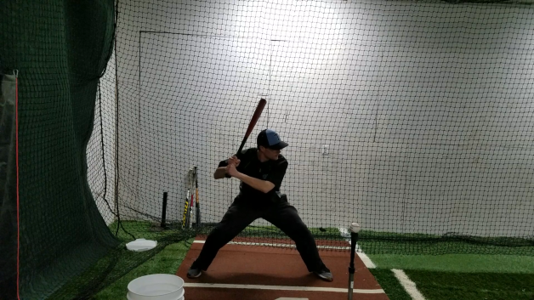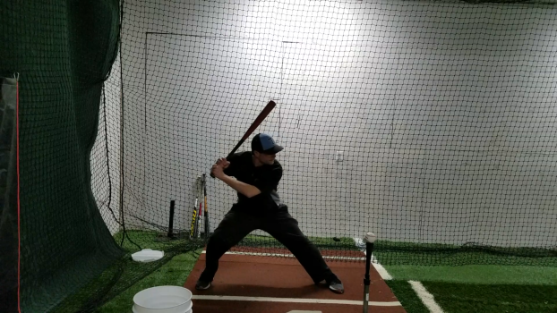
Figure 1: Starting position for low & spread out drill Figure 2: Shifting back to create momentum in legs
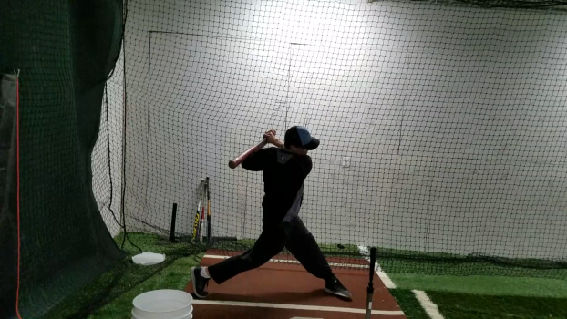
Figure 3: Finished position, body remains in same low position as it began

How it works: The goal of the hitter is to take a full swing, but stay low through its entirety. Since they are spread out wide, they will not be striding. Instead, they will be shifting their weight back and forward to create momentum in their legs. Without shifting back and forward the hitter will only be able to use their arms to swing. We want a full, hard swing that uses the whole body! Notice in the picture above, at the completion of the swing I have turned fully and have kept my head at roughly the same height that it began.

SEPARATE TO LAUNCH DRILL (Separation)
“Keep your hands back!” I’m sure you’ve heard this phrase. Well what exactly does this mean? And how do we actually keep our hands back? A better name for this is separation. It means that while a hitter strides forward and their body is gaining ground, their upper body needs to resist that movement and stay closed and back. The hitter should feel their back arm and shoulder pulling back against their body's forward move. A way to visualize this is that it is movement much like your arm would make when pulling a bow string back to shoot an arrow, or like you're pulling a lawn mower string to start it. This movement is critical for being able to do things like hit the outside pitch, hit an off speed pitch, and hit with power.
Set up: This drill can be done off of a tee or with side or front toss. Hitter will be starting with their feet together. They should get to this position by bringing their front foot back to meet their back foot. This way they are still behind the tee after they land their stride.
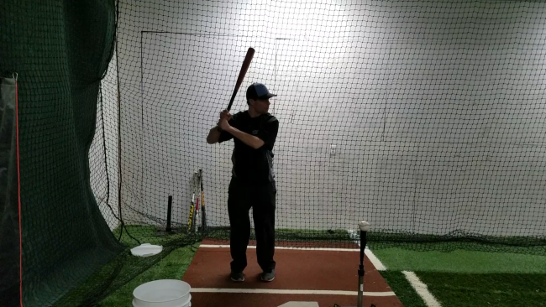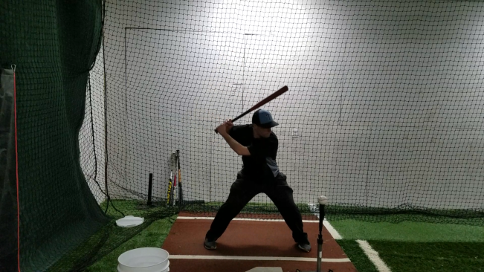
Figure 1: Bring front foot back; close to the back foot Figure 2: Practice landing in a good position

How it works: The hitter will first need to do a few reps of the movement without swinging. From the feet together stance, have them stride out to their normal landing spot, land and freeze in a loaded position. Make sure there is no slack in your upper body. Their scap muscle by their rear shoulder blade should be tight when they land, their back elbow should be at shoulder height, and their shoulders angled slightly downhill. Have them hold for a couple seconds, then repeat. After the hitter perfects the movement, have them stride, separate and finish the swing without stopping. Make sure they are actively pulling their upper body back and are getting out to the same athletic landing position on every stride.

WALK IN DRILL W/ PITCH (Rhythm)
You may or may have not heard the term, “start slow and early.” What this means is that it is beneficial for a hitter to begin their first movements (gather, load and stride) early, and to make those moves slow and controlled. It helps a hitter create consistency, get their movements in sync with a pitcher’s movements, and ultimately helps them see the pitch and time the ball better.
Set up: This drill can be done with any variation of batting practice. It is great on the tee, but if you really want to work the timing side of the drill, add it into your soft toss and live batting practice routine.
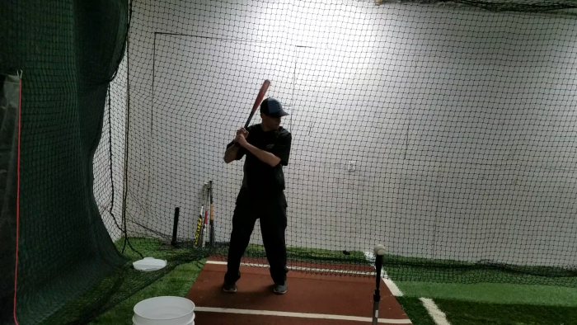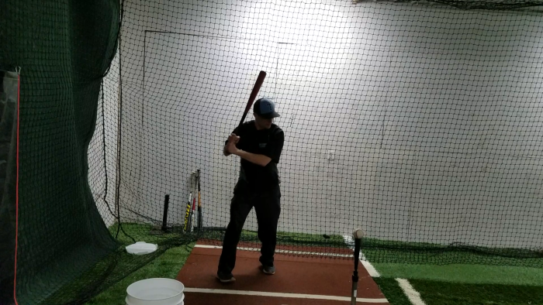
Figure 1: Begin one step back away from the plate Figure 2: Back foot initiates drill by stepping into position

How it works: The hitter will begin one step back from the position in which they usually stand in the batter’s box. They will then take a small step forward with their back foot, and in one continuous movement, they’ll work into their stride, get to a hitting position, and swing. If this is being done as a underhand toss or overhand pitch drill, the hitter must synchronize their step with the coach’s movement. If they are stepping in at a controlled and rhythmic pace, they’ll probably need to begin walking in as soon as the coach begins to move their arm back to throw. The hitter’s goal is to time it so that they are not early to the point of getting back to their spot and having to freeze, but they are also not late to the point that they feel hurried or cannot take a full, smooth swing.

MIXED SPEEDS DRILL (Timing)
I’ve heard people say that timing cannot be learned or developed, but personally, I think that is absurd. The easiest way to help hitters hone in their timing is to let them see varied speeds regularly.
Set up: It’s easiest to mix speeds in a controlled manner with underhand front toss. So you’ll need a protective screen.
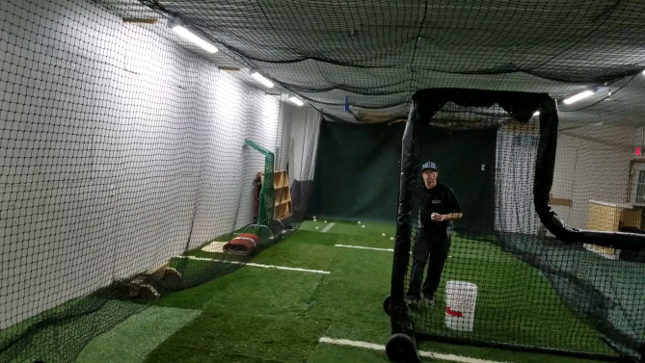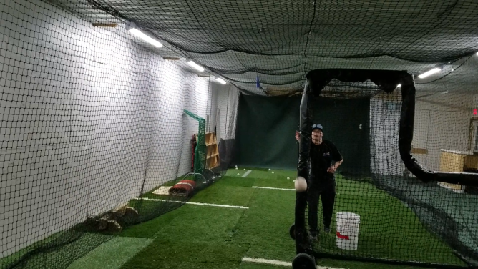
How it works: Begin by showing the hitter what your “fastball” and your “changeup” look like. Vary the pitch speed by taking a little off your underhand toss for the “changeup.” Try to make your arm movement appear the same on both the fastball and changeup. Have the player hit each underhand toss speed several times, while knowing what speed is coming. After they find some success with this, tell them that you will no longer let them know which speed is coming. Randomly mix between the fast and slow speeds, making sure not to fall into any sort of pattern.

SWING AT EVERYTHING DRILL (Aggressiveness)
Many youth hitters tend to have a backwards approach at the plate. It’s backward in the sense that they wait to see if a pitch is good before they even begin to think about swinging at it. The correct and more aggressive approach is to expect a good pitch, prepare your mind and body to swing at it, and then hold off at the last split second if it is not a good pitch. If a hitter is consistently late, this backward thinking may be a contributing factor. This drill helps them see what it’s like when they are more aggressive minded.
Set up: Like mixing speeds, it is easiest to vary location in a controlled manner with underhand front toss. So again, you’ll need a protective screen. Make sure the hitter knows that you will be intentionally wild with your tosses, and that you want them to hit every toss.

How it works: Toss the ball all around the plate, inside and outside of the strike zone. Try to stay within a foot of each corner of the plate, at least a few inches off the ground, and at or below the hitter’s head height. You’re trying to be wild, while still allowing them the chance to make contact with every toss. The hitter will probably struggle at first, but with more tries, they will quickly adapt with better balance and body control to make contact with more tosses. They’ll then realize with an aggressive approach, good balance and body control, that they can hit many different pitch locations hard. After 15-20 wild tosses, the hitter should be gaining some confidence with this aggressive approach. Tell them to keep the aggressive approach, but that the next 5 tosses will be within the strike zone. Flip 5 very hittable pitches. The hitter will most likely see and hit these final 5 tosses very well.

AGE SPECIFIC DRILLS

Hand-eye coordination

A skill that is often overlooked in training young baseball players is hand-eye coordination. Here are a couple drills that can help them develop this skill:
Frisbee Catch
Frisbees are a fantastic tool for hand-eye coordination and for simulating the thumb to finger squeeze that happens when catching with a baseball glove. Use them creatively to improve your players’ glove hand abilities.
Barehanded Drills
Many times young players get away with incorrect movements with the glove. Take the glove away and they can no longer get away with it. Bare hand drills are a fantastic way to improve hand-eye and use of the glove hand. You can modify just about any defensive drill to be a bare handed drill.

Tennis Ball Wall Ball
Have player stand facing a wall about 10 feet away. Stand behind the player, out of his line of sight. Using a tennis ball or other bouncy softer ball, toss the ball past the player and bouncing it off the wall. The player will react and catch the ball with his glove hand. If you need to make it more difficult, move the player closer to the wall.

Baserunning
HOW YOU UTILIZE FOLLOWING BASERUNNING SECTION OF THE HANDBOOK IS DEPENDENT ON THE AGE GROUP AND THE RULES WITHIN YOUR LEAGUE OR TOURNAMENTS.
Some leagues and tournaments allow lead-offs and steals at much younger ages than others. MAKE SURE you are familiar with the baserunning rules that your team will be playing under this season!
Once you know the rules, practice it daily after your warm up. Have your players begin on the foul line and imitate a pitcher in their line of vision. Here are a few things you should practice:

Primary Lead and Secondary Leads
Primary lead – Three and a half steps off of the bag should be equal to the distance at which a player will need to take a step and a dive to get back to the bag. Practice getting to that distance. While taking a primary lead, try to avoid taking eyes off the pitcher or turning hips and shoulders completely toward 2B. Once at full distance, end up in an athletic stance with front foot slightly turned open toward 2B. Always take leads in line with the back of the base, and when a pitcher throws over, go back in to the back of the base.
Secondary Lead – As the pitcher goes to the plate, the runner at first or second should give two full shuffles. Runners should try to gain as much ground as possible, not hop up in the air while shuffling. The runner should keep their hips and shoulders square to home plate until the direction they are headed next is determined. If the ball is not put in play, the runner should then sprint back to the bag.
Straight Steals w/ Pick off Attempts
Begin practicing straight steals with a coach acting as the pitcher, then progress to pitchers on your team working against baserunners. Runners will get out to their primary lead positions. Tell them to try to determine what the first move of the pitcher is when he goes to the plate (for RH pitchers you will generally see their front heel pick up first when they go to the plate). Players will take off on a dead sprint to 2B immediately after determining the pitcher is going to the plate. They should try to stay low and gain as much ground as possible on their cross over step. Have the coach or pitcher mix in pick off moves. Runners should work on taking a step and a dive back into the bag with their face turned away and reaching to the back corner of the bag with their right hand. If the rules of your league or tournaments say that you cannot leadoff, practice straight stealing directly from the base. Runners will have to wait for the ball to reach home plate to take off.
Dirt Ball Reads
Work on having your players read a pitched ball that is going to be in the dirt. If they are confident and aggressive with this skill, they will take that extra base much more frequently. You can use a catcher or a screen to throw to while acting as the pitcher. Have players shuffle off into a secondary lead as you go to the plate. As soon as they determine that the ball is not going to make it to the screen or catcher on the fly, they can take off in a sprint to second base. If they determine the ball is going to make it to the catcher, they will stop after their secondary lead and sprint back to the bag.

PRACTICE PLANS

*Pre Season*

Example Two (120 Minutes)
Dynamic warm up routine (10 Minutes)
  - Hip mobility exercises
  - Core strength exercises
  - Agility exercises
  - Other fun exercises

Leads and Steals from Foul Line (5 Minutes)
Throwing Program (10 Minutes)
Positional Daily Drills/Fungos (10 Minutes Total)
- Two groups, one working on daily positional drills, other taking fungo groundballs or fly balls, switch after 5 minutes
Water Break and Transition/Pitcher Warm Up Time (5 Minutes)
3 Man Scrimmage (50 Minutes)
- Break team up into groups of 3
- Have pitchers and catchers evenly distributed among groups
- Each team will hit for a given amount of time (for example 3 groups of 3, each group hits for 15 mintues)
- Leave extra time for transition of teams and pitchers and catchers
- Remaining teams will play defense
- Group that scores most runs wins
- CAN ALSO BE DONE WITH COACH PITCHING TO SAVE TIME OR ARMS!!!

Example Two (120 Minutes)
Dynamic warm up routine (10 Minutes)
- Hip mobility exercises
- Core strength exercises
- Agility exercises
- Other fun exercises
Throwing Program w/ Long Toss (10 Minutes)
Leads and Steals from Foul Line (4 Minutes)
Positional Daily Drills (10 Minutes)
Water Break (3 Minutes)
Defense: two groups, rotate everyone after 10 min (20 Minutes total)
- Infield – Fungo groundballs
- Outfield – Fungo flyballs
20 Minute Hitting/Pitching Rotations (Two Groups – 40 Minutes total)
- Hitting Drill Routines (batting cages) – Multiple coaches flipping or throwing to get as many swings as possible in 20 minutes.
- Hitters vs. Pitchers (on field) – Pitchers will throw a predetermined amount of pitches to the rest of the hitters in their group. Hitters can hit each pitch and will stay up for 6 to 8 pitches, then switch. USE CATCHERS WHEN POSSIBLE!
Water Break (3 Minutes)
Situational Practice w/ Coaching on Team Concepts (30 Minutes)
- Coaching points:
    - Positional responsibilities
    - Baserunning
    - Backup responsibilities
    - Cut offs and Relays
    - Any other team concepts you want to focus on
- Options:
- Coach Fungos
- Live Baserunners
- Live Hitters (can be done off of coach pitch, tee or soft toss, or live pitchers.)
- Positional rotation (Can be done w/ 10 players [9 w/ coach on defense] or more)
- 3 Man Scrimmage, Coach Pitched (Must have full group of 12 or have coaches play defense w/ less players)

*In Season*

Example One (90 Minutes)
Dynamic warm up routine (10 Minutes)
- Hip mobility exercises
- Core strength exercises
- Agility exercises
- Other fun exercises
Leads and Steals from Foul Line (4 Minutes)
Throwing program (10 Minutes)
Positional Daily Drills or Position Specific Work (10 Minutes)
Water Break (3 Minutes)
Defense (split team in half and make one rotation) (20 Minutes total)
  - Infield (10 min)
  - Outfield (10 min)
Water Break (3 Minutes)
Hitting Rotations (30 Minutes)
- Use cages and field if possible. We want the players to get as many swings as possible in allotted time. Use all volunteers available to create as many stations as you can. Use different drill work, dry swings, live hitting, whiffle ball hitting, etc. There should be very few players standing around during this time.

Example 2 (120 Minutes)
Dynamic warm up routine (10 Minutes)
- Hip mobility exercises
- Core strength exercises
- Agility exercises
- Other fun exercises
Leads and Steals from Foul Line (4 Minutes)
Throwing program (10 Minutes)
Positional Daily Drills or Position Specific Work (10 Minutes)
Water Break (3 Minutes)
Team Defense (25 minutes)
Let players get plenty of defensive reps. Options include:
- Fungos at position
- Infield/Outfield practice
- Pop up communication
- Infield group and outfield group
- Drill work with rotations
Situations/Team Concept Review (25 minutes)
- Work on concepts that the team continues to struggle with or that they need to review. You can rotate baserunners in and out to work on baserunning at this time as well.
Water Break (3 minutes)
Hitting Rotations (30 minutes)
- Use cages and field if possible. We want the players to get as many swings as possible in allotted time. Use all volunteers available to create as many stations as you can. Use different drill work, dry swings, live hitting, whiffle ball hitting, etc. There should be very few players standing around during this time.

